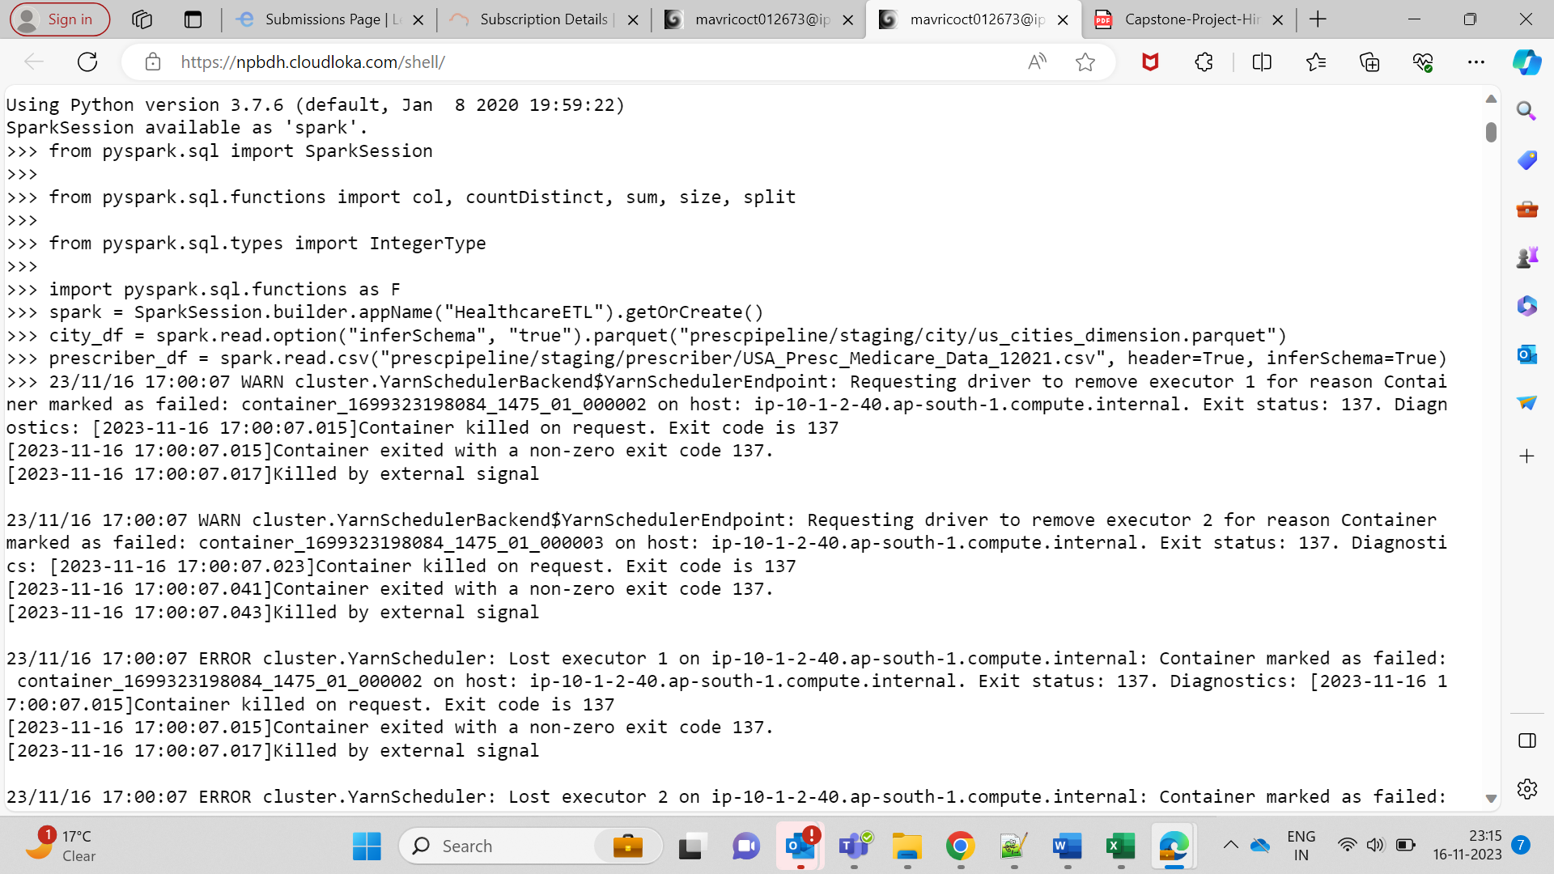  
  
Null columns counts  
  
**Prescriber Report-**  
  
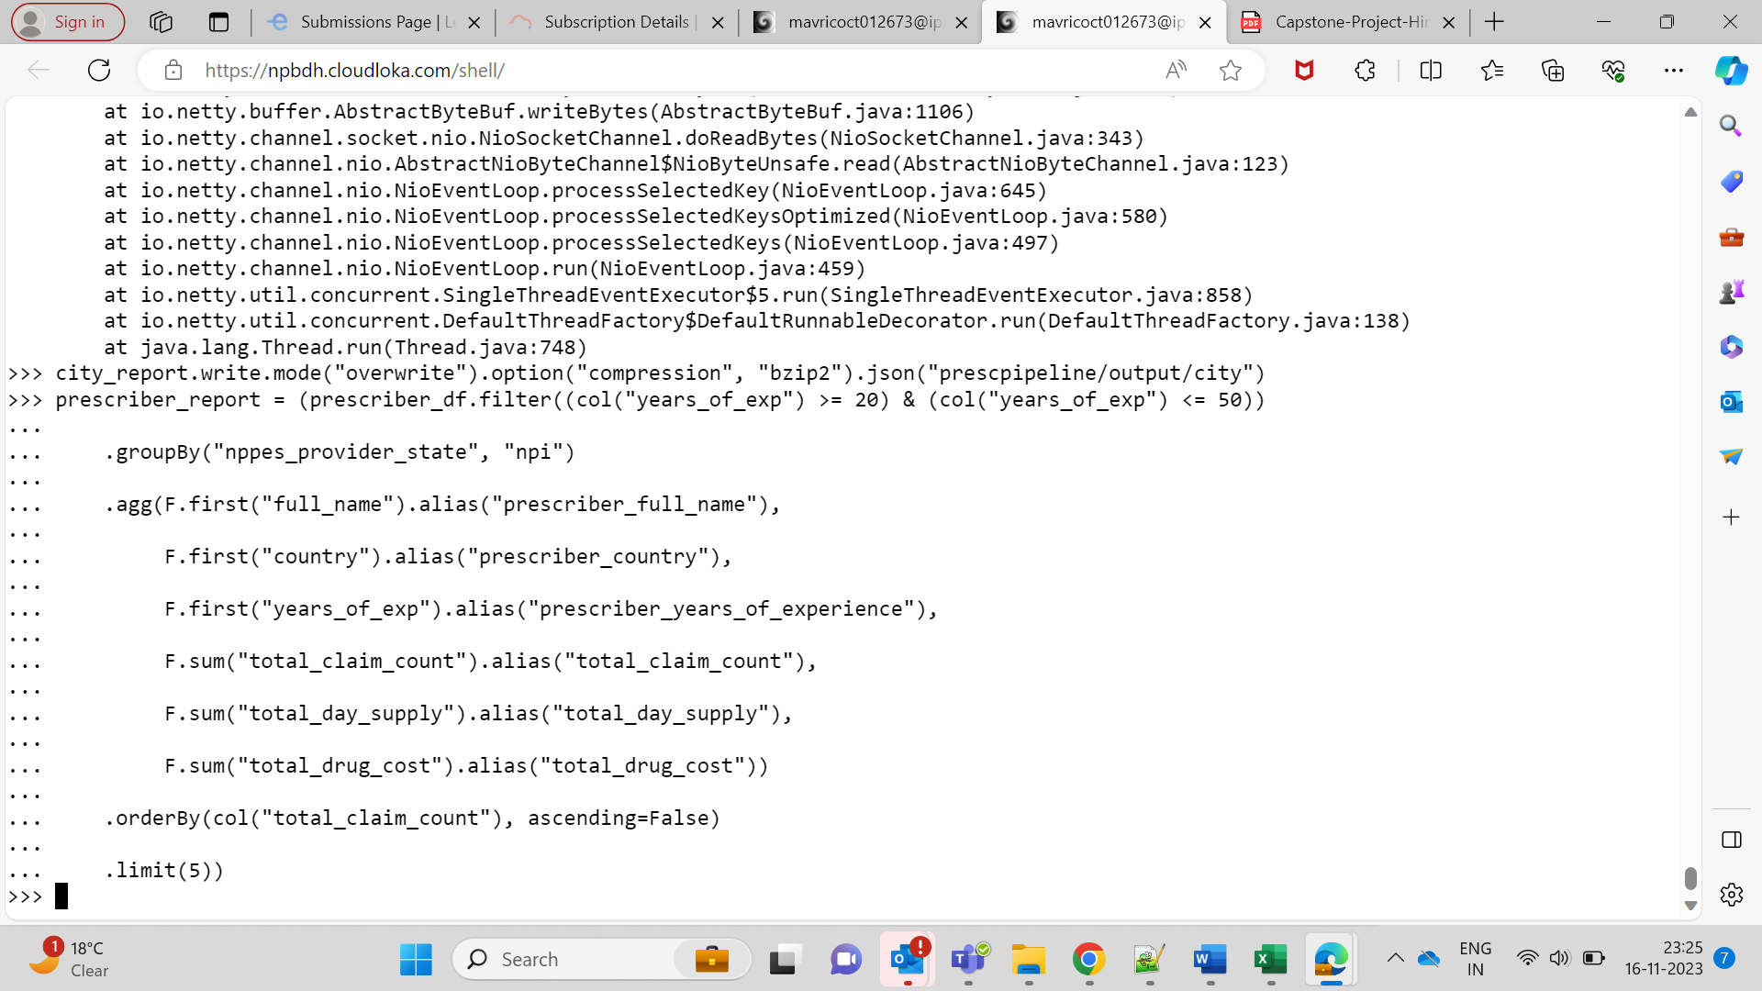  
  
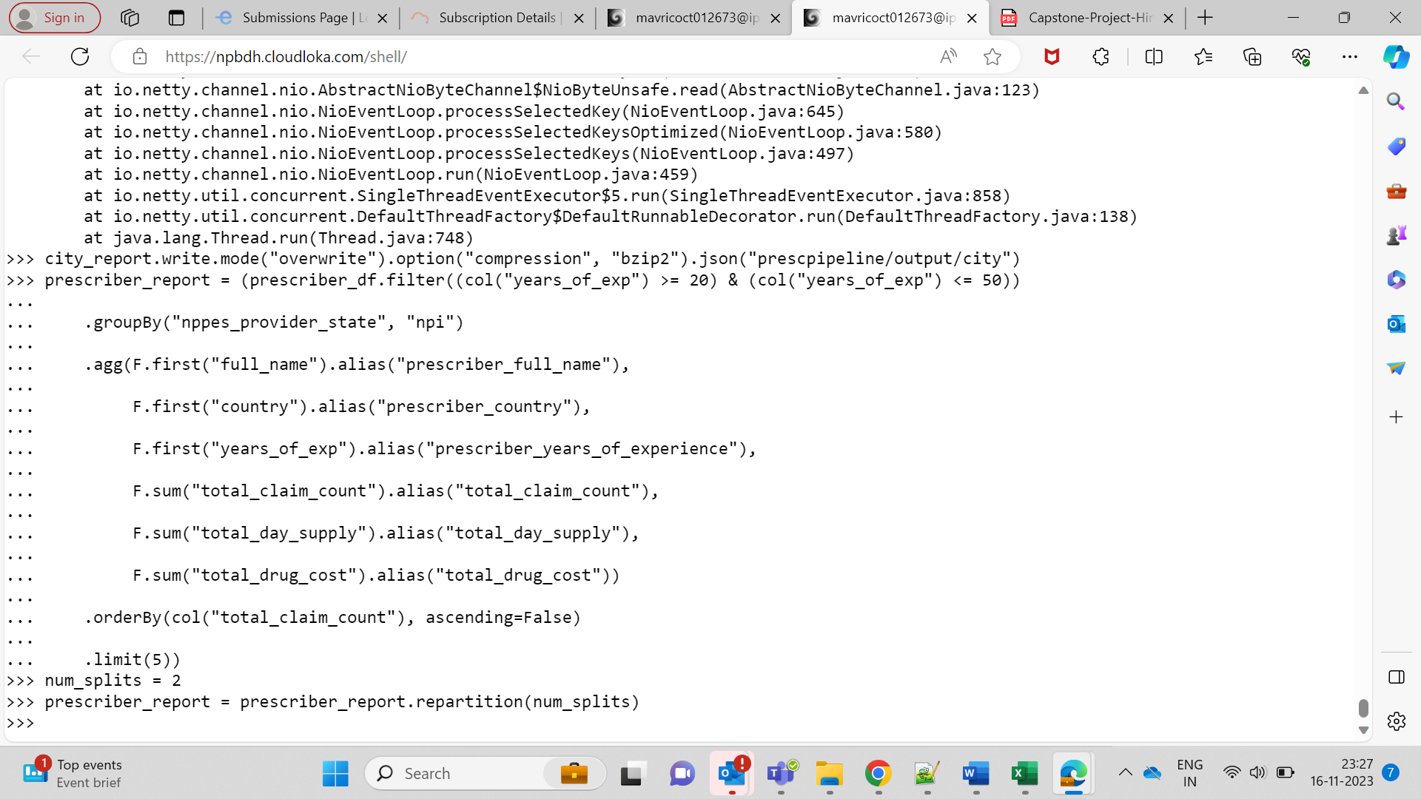  
  
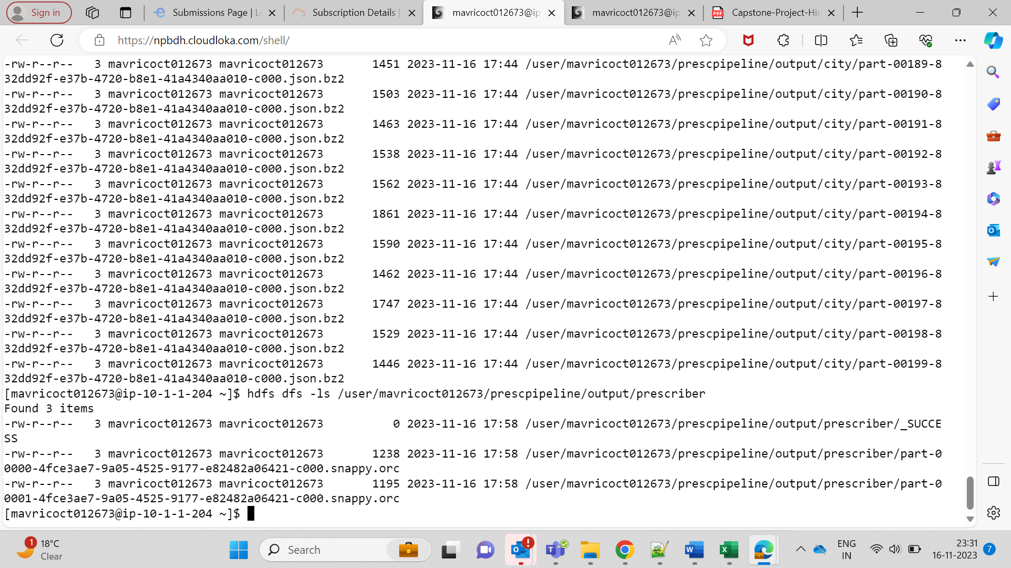  
  
  
from pyspark.sql import SparkSession

from pyspark.sql.functions import col, countDistinct, sum, size, split

from pyspark.sql.types import IntegerType

import pyspark.sql.functions as F

# Step 1: Initialize Spark session

spark = SparkSession.builder.appName("HealthcareETL").getOrCreate()

# Step 2: Data Ingestion

city_df = spark.read.option("inferSchema", "true").parquet("prescpipeline/staging/city/us_cities_dimension.parquet")

prescriber_df = spark.read.csv("prescpipeline/staging/prescriber/USA_Presc_Medicare_Data_12021.csv", header=True, inferSchema=True)

# Step 3: Data Cleansing

# Clean City Data

city_df = (city_df

.select("city", "state_id", "state_name", "county_name", "population", "zips")

.withColumn("city", col("city").cast("string"))

.withColumn("state_id", col("state_id").cast("string"))

.withColumn("state_name", col("state_name").cast("string"))

.withColumn("county_name", col("county_name").cast("string"))

.withColumn("population", col("population").cast("integer"))

.withColumn("zips", col("zips").cast("string"))

.withColumn("number_of_zips", size(split(col("zips"), ","))

)

# Clean Prescriber Data

prescriber_df = prescriber_df.select("npi", "nppes_provider_last_org_name", "nppes_provider_first_name",

"nppes_provider_city", "nppes_provider_state", "specialty_description",

"drug_name", "total_claim_count", "total_day_supply", "total_drug_cost") \

.withColumnRenamed("nppes_provider_last_org_name", "last_name") \

.withColumnRenamed("nppes_provider_first_name", "first_name") \

.withColumn("country", F.lit("USA")) \

.withColumn("years_of_exp", F.regexp_extract(col("years_of_exp"), r"(\d+)", 1).cast(IntegerType())) \

.withColumn("full_name", F.concat(col("first_name"), F.lit(" "), col("last_name"))) \

.na.drop(subset=["npi", "drug_name"])

# Count the number of null values for each column

null_counts = prescriber_df.select([count(when(col(c).isNull() | isnan(col(c)), c)).alias(c) for c in prescriber_df.columns])

# Clean all the Null/Nan Values

prescriber_df = prescriber_df.na.drop(subset=["npi", "drug_name"])

# Step 4: Data Transformation for City Report

# Calculate the number of zips in each city

city_df = city_df.withColumn("number_of_zips", size(split(col("zips"), ",")))

# Calculate the number of distinct Prescribers assigned for each City

prescriber_counts = prescriber_df.groupBy("nppes_provider_state", "nppes_provider_city").agg(

countDistinct("npi").alias("prescriber_counts"),

sum(col("total_claim_count").cast("int")).alias("total_claim_counts")

)

# Join dataframes using state_id and nppes_provider_state

city_report = city_df.join(

prescriber_counts,

(city_df.state_id == prescriber_counts.nppes_provider_state) & (city_df.city == prescriber_counts.nppes_provider_city),

"left_outer"

)

city_report = city_df.join(

prescriber_counts,

(upper(city_df.state_id) == upper(prescriber_counts.nppes_provider_state)) &

(upper(city_df.city) == upper(prescriber_counts.nppes_provider_city)),

"left_outer"

)

# Filter out cities with no prescriber assigned

city_report = city_report.filter(city_report.prescriber_counts > 0)

# Select the required columns

city_report = city_report.select("city", "state_id", "state_name", "county_name", "population", "number_of_zips", "prescriber_counts", "total_claim_counts")

# Show the final City Report

city_report.show()

# Save the City Report as JSON with Bzip2 compression

city_report.write.mode("overwrite").option("compression", "bzip2").json("prescpipeline/output/city")

# Step 4: Data Transformation for Prescriber Report

prescriber_report = (prescriber_df.filter((col("years_of_exp") >= 20) & (col("years_of_exp") <= 50))

.groupBy("nppes_provider_state", "npi")

.agg(F.first("full_name").alias("prescriber_full_name"),

F.first("country").alias("prescriber_country"),

F.first("years_of_exp").alias("prescriber_years_of_experience"),

F.sum("total_claim_count").alias("total_claim_count"),

F.sum("total_day_supply").alias("total_day_supply"),

F.sum("total_drug_cost").alias("total_drug_cost"))

.orderBy(col("total_claim_count"), ascending=False)

.limit(5))

# Set the desired number of splits (output files)

num_splits = 2

# Repartition the DataFrame to control the number of output splits

prescriber_report = prescriber_report.repartition(num_splits)

# Write the Prescriber Report in ORC format with Snappy compression and overwrite the output directory if it exists

prescriber_report.write.mode("overwrite").orc("prescpipeline/output/prescriber")

from pyspark.sql import SparkSession

# Initialize a Spark session

spark = SparkSession.builder.appName("OpenORCFile").getOrCreate()

# Specify the path to the ORC file

orc_file_path = "prescpipeline/output/prescriber"

# Read the ORC file

prescriber_report = spark.read.format("orc").load(orc_file_path)

# Show the content of the ORC file

prescriber_report.show()

# Step 6: Stop the Spark session

spark.stop()